**Payeer for CMS Opencart 3.0.x**

Go to the admin panel of your site. Go to the menu "Extensions -> Installer” and click "Upload”.

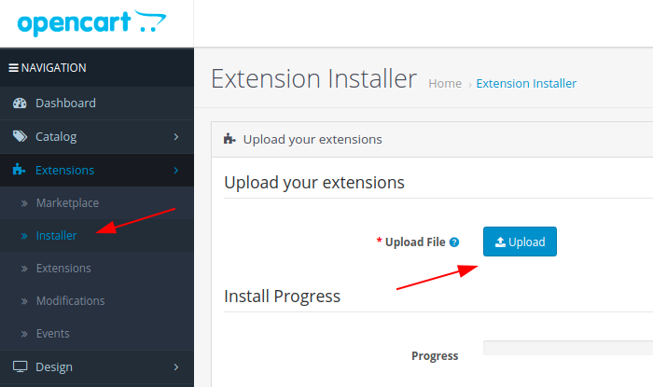

In the Explorer, select the downloaded archive payeer.ocmod.zip

After successfully installing the extension, go to the menu

"Extensions -> Extensions”.

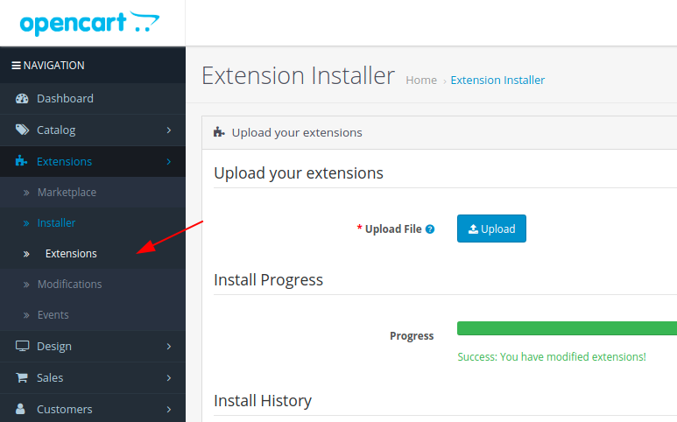

Select the “Payments”extension type from the list.

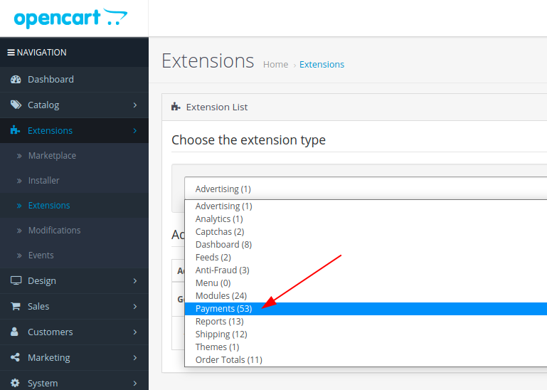

The Payeer module should be displayed in the list of payment systems.

Click on the button to install the Payeer payment module.

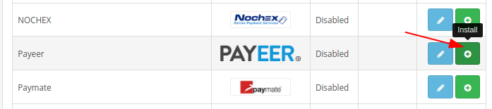

After installation, click on "Edit”

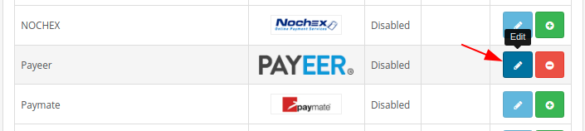

Fill in all the necessary fields:

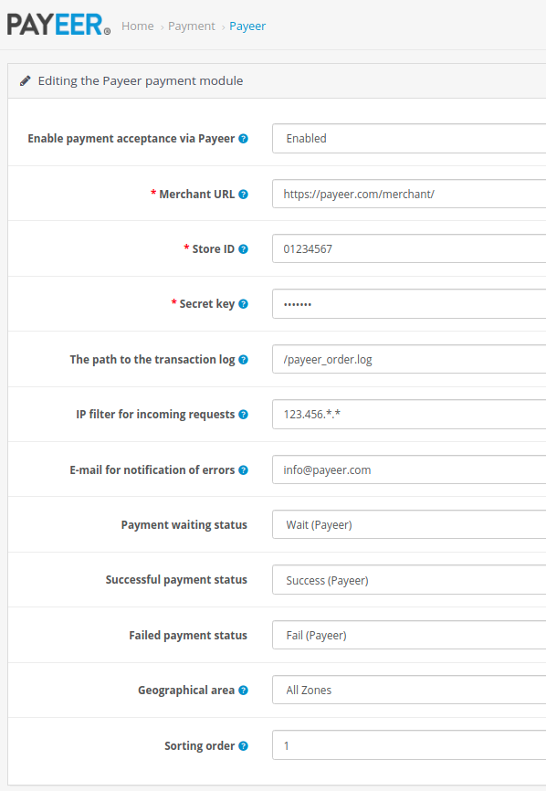

**URL merchant**: link to payment system Payeer in (default <https://payeer.com/merchant/>);

**ID shop**: ID of your store in the system Payeer (can be found in the personal cabinet);

**Secret key**: the secret key of your store, you can also find in the personal cabinet;

**The path to the transaction log**: the path to the file intended to record the history of payment transactions in the payment system Payeer;

**IP filter incoming requests**: IP filter incoming requestsYou can specify the list of all trusted ip addresses of servers, separated by commas. You can also specify a mask instead of the ip address. If the field is empty, checking for trusted ip addresses is not performed.

For example:

192.168.71.87, 192.165.83.17, 192.178.34.15

Or 192.*.71.87, 192.165.83.*, 192.*.34.*

Or *.*.*.* - all available ip addresses;

**E-mail alert for Error**: email will be sent notifying you in case of an error of payment. The letter will state the reason and basic information about the payment;

Specify the status of orders payment

1. **Status of waiting for payment** (default, Pending);
2. **Status of successful payment** (default, Complete);
3. **Status of failure of payment** (default, Failed);

**Geo zone**: geographic area where affordable payment method;

**Sort order**: the order in the list of available payment methods.

Save the changes.

Specify the URLs in "Payeer account → API → Settings”

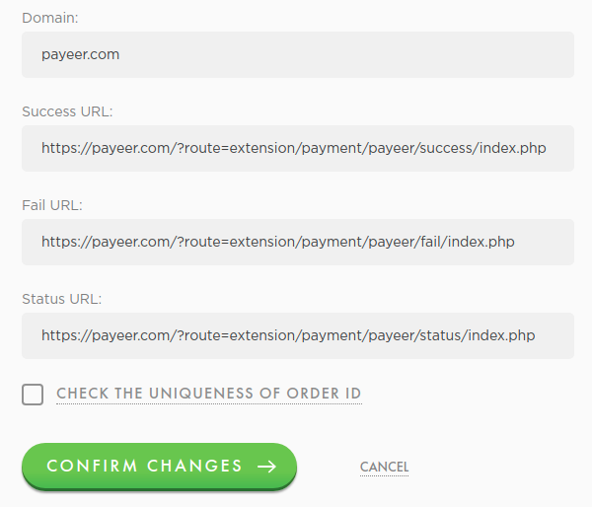

Success URL:

https:// *****/?route=extension/payment/payeer/success/index.php

Fail URL:

https:// *****/?route=extension/payment/payeer/fail/index.php

Status URL:

https:// *****/?route=extension/payment/payeer/status/index.php

Where ***** is your domain.

Confirm changes.  
Payeer module for CMS Opencart 3.0.x configured.